Welcome to the 58th
North Carolina Federation
of Chapters Annual Convention

NATIONAL ACTIVE AND RETIRED
FEDERAL EMPLOYEES ASSOCIATION

“Respecting the Past – Creating the Future”

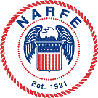

PROGRAM BOOKLET

ROCKY MOUNT, NC

May 6 – 8, 2014

Blank Inside Cover

TABLE OF CONTENTS

In Memoriam – Paul E. Sams………………………………….…….….1
Welcome, NC Federation President Sam Crain…………………….…..2
Welcome, Host Committee Chair Robert Allen………………………...3
Welcome, Mayor David W. Combs, Rocky Mount, NC.................….…4
Welcome, Rocky Mount Chamber of Commerce…………………..…..5 4
Welcome, David L. Joyner, Marketing Dir., Gateway Ctr. Complex.….6
Convention Schedule
- Tuesday………………………………………………..……..8-9
- Wednesday…………………………………………….…..10-11
- Thursday……………………………………....……...….12
2013 – 2014 Federation Executive Board……………...……….…..…13
Speakers Bios
- Sam Crain, Federation President…………………...…………14
- Mayor David W. Combs, Rocky Mount, NC………....……....15
- Bill Shackelford, Co-Chair, Future of NARFE Committee…..15
- Jessica Klement, NARFE Legislative Director……….…...….16
- William F. Martin, Region X Vice President…………………17
- Bridget Boel, NARFE Membership Director………….…...…17
Lyle V. Storch Award and Recipients………………………...…...18-19
Charles R. Patton “Good Egg” Award and Recipients….…..….....…..20
Past Federation Presidents…………………………….………...……..21
2014 Convention Planning Committee………………………......……22
2013-2014 Federation Committee Members………………...….....23-24
Special Appreciation and Thanks…………………………….......……25 23
Welcome to the 2015 NC Federation Convention in Hickory, NC…....28 26

In Memoriam

Paul E. Sams

North Carolina Federation President
2010-2012

Sandhills Chapter 1895 President
2014

A great advocate for the
people of NARFE
and this convention is
dedicated to his memory

North Carolina Federation of Chapters
NATIONAL ACTIVE AND RETIRED FEDERAL EMPLOYEES ASSOCIATION

Fifty-Eighth Annual Convention
May 6 – 8th, 2014, Rocky Mount, NC
“Respecting the Past – Creating the Future”

May 6, 2014

NARFE Members and Guests:

On behalf of the North Carolina Federation of Chapters, I welcome each delegate, member, guest and “first timer” to the Fifty-Eighth annual convention. We hope all of you find this year’s convention welcoming, inviting, and informative.

The convention planning committee worked energetically to provide the best possible setting for this event, as well as informative speakers on issues of importance. Our special guests include Bill Shackelford, Co-Chair of NARFE’s Future of NARFE Committee, Jessica Klement, NARFE Legislative Director, Bridget Boel, NARFE Membership Coordinator, who will speak to us from Headquarters, and Region X Vice President William F. Martin, who will update us about news from around the region.

Thanks to the Area IV chapter members for organizing this convention.

Again, welcome to your 58th Annual Convention. I encourage all of you to enjoy the beautiful coastal plain surrounding the Rocky Mount area and the several amenities the region has to offer.

Sam Crain, President
NC Federation of Chapters

North Carolina Federation of Chapters
NATIONAL ACTIVE AND RETIRED FEDERAL EMPLOYEES ASSOCIATION
Fifty-Eighth Annual Convention
May 6 – 8th, 2014, Rocky Mount, NC
“Respecting the Past – Creating the Future”

WELCOME

May 06, 2014

Welcome to the All-American City of Rocky Mount, the one-time home of Hardee’s and a major stop between New York and Miami. (Highway signs on I-95 just north of Richmond, VA have displayed mileage to Rocky Mount and then to Miami!) Rocky Mount had its beginning in the early part of the 19th century, centering on the first post office established at the Falls of the Tar River on March 22, 1816. It was at that point that the name Rocky Mount appeared in documented history.
The name doubtless derived from the rocky mound at the falls of the Tar River, which was also the site of one of the first cotton mills in North Carolina: Rocky Mount Mills was established in 1818. The Wilmington-Weldon Railroad was built about 2 miles east of the mill in 1845 and became the main connection for Rocky Mount to the outside world. The City of Rocky Mount incorporated in 1867 and, with a population of some 57,000 continues to thrive as an economic and cultural engine for the northern coastal plain of North Carolina.
The Host Committee extends “Thanks and Appreciation” to all Chapters, Sponsors, Delegates, Advertisers, Speakers, Exhibitors and friends for their generosity, their participation and support. Please call on host members for assistance in making this Convention a SUCCESS.
THANK YOU!
Sincerely,
Robert Allen
Robert Allen
2014 Host Committee Chair

Insert Original Letter From
City of Rocky Mount
Office of the Mayor

Insert Original Letter From
Rocky Mount
Chamber of Commerce

Insert Original Letter From
Gateway Centre Hotel Complex

Original Advertisement from

Blue Cross Blue Shield

North Carolina Federation of Chapters
Fifty-Eighth Annual Convention
“Respecting the Past – Creating the Future”

Tuesday, May 6th

8:30 AM - 11:30 AM Exec. Brd Meet Camellia/Azalea Rm, DoubleTree
9:30 AM - 5:00 PM Registration, Credentials
and Exhibitors’ Tables Gateway Centre Foyer

1:00 - 4:15 PM COMMITTEE MEETINGS LOCATION
1:00 - 1:45 PM Audit Camellia Room DoubleTree
1:00 - 1:45 PM Nominating Azalea Room DoubleTree
1:00 - 1:45 PM Rules Magnolia Room DoubleTree
1:00 - 1:45 PM Ballot and Teller Dogwood Room DoubleTree
1:00 - 1:45 PM Bylaws Executive Board Rm DoubleTree
1:45 - 2:30 PM Budget Camellia Room DoubleTree
1:45 - 2:30 PM Legislative Suite 107 Outside Gateway
1:45 - 2:30 PM Sgt-At-Arms Azalea Room DoubleTree
1:45 - 2:30 PM Resolutions Magnolia Room DoubleTree
1:45 - 2:30 PM Courtesy Dogwood Room DoubleTree
1:45 - 2:30 PM Credentials Executive Board Rm DoubleTree

OPENING SESSION CLUB ROOM - GATEWAY
3:45 PM Door Prize Drawing Cheryl Allen

4:00 PM
Call to Order Sam Crain, President
Recognition of Chapter Banners Sam Crain, President
Invocation Rev. Peter Byrum, 1st Presbyterian Church
Posting of Colors Northern Nash High School JROTC,
Lt. Col. Crudup, Commanding Officer
Pledge of Allegiance Sam Crain, President
Host Comm. Welcome and Intro’s Robert Allen, Host Committee Chair
Welcome Address Mayor David W. Combs, Rocky Mount Welcome, Gateway Conv. Centre Jacqui Elder, Group Sales/Catering Coor.
Welcome, NARFE Headquarters NARFE President Joseph A. Beaudoin
Response to Welcome Ron Buffaloe, Executive Vice President
Recognition of “First Timers” Sam Crain, President
Introduction of Head Table Sam Crain, President
and Officers and Guests

TUESDAY, May 6th (continued)
BUSINESS SESSION I CLUB ROOM - GATEWAY
Introduction of Sponsors Sam Crain, President
Remarks by GEHA Benita Thomas, Account Exec.
Remarks by MHBP Angela Holt, National Acct. Mgr.
Remarks by BC/BS Patsy Ziegler, Group Consultant
Introduction of Committee Chairs Ron Buffaloe, Exec. Vice President
FEDERATION COMMITTEES
Audit Committee Chair Evelyn Ellis, Chapter 2107
Ballot & Teller Committee Chair Harriet Bartlett, Chapter 1312
Budget Committee Chair Merrill D. Jackson, Chapter 192
Bylaws Committee Chair Bill R. Austin, Chapter 105
Courtesy Committee Chair Sharrill Jennings, Chapter 337
Credentials Committee Chair Thomas Rogers, Chapter 2206
Legislative Committee Chair John Allis, Chapter 192
Nominating Committee Chair Sue Hawkins, Chapter 1791
Resolutions Committee Chair Betty Whitten, Chapter 668
Rules Committee Chair Walter R. Mack, Chapter 2208
Sergeant at Arms Committee Chair Nate Johnson, Chapter 2211
COMMITTEE REPORTS
First Credentials Committee Report Thomas Rogers, Chair
Rules of the Convention, Rules Committee Walter R. Mack, Chair
First Nominating Committee Report Sue Hawkins, Chair
5:30 PM - ADJOURN BUS. SESSION UNTIL 8:30 AM WEDNESDAY MAY 7th

7:30 PM - BCBS & NC FEDERATION RECEPTION – CARDINAL & CLUB RM
WEDNESDAY MORNING, May 7th
BUSINESS SESSION II CLUB ROOM - GATEWAY

8:15 AM Door Prize Drawings Cheryl Allen

8:30 AM

Call to Order Sam Crain, President
Invocation Rev. Glenn Hill,
Shenandoah Baptist Church
Pledge of Allegiance Sam Crain, President
Credentials Committee Report Thomas Rogers, Chair
Introduction of Speaker Sam Crain, President
“The Future of NARFE” Bill Shackelford, Comm. Co-Chair

10:00 – 10:15AM BREAK

2013 Convention Minutes Carolyn C. London, Secretary
Federation Treasurer’s Annual Report Gracie W. Couch, Treasurer
Region II VP Candidate Jerry Janci Cindy Bourassa, Daughter
Election Process Sam Crain, President
Final Nominating Committee Report Sue Hawkins, Chair
Nominations from the Floor
Introduction of Candidates for Federation Offices - Candidates Forum
Sergeant-at-Arms Announcement

Recess: All Delegates Adjourn to their Area Caucus

11:15 AM Area Caucuses

Area Vice Presidents will chair their caucuses, including election of the new Area V.P. This also is an opportunity to discuss Area and Chapter business with the Area V.P. The Area V.P. will ask first for nominations from the Area member of the Nominating Committee and then from the floor and will conduct the election. The gavel will remain with the current Area V.P. to preside for the remainder of the meeting.

The outgoing Area V.P. recognizes the newly elected Area V.P. and offers him/her the opportunity to speak, but the new Area V.P. will not assume responsibility until after he/she has been sworn in during the regular assembly. Delegates shall return to the general assembly room not later than 1:00 PM. The Nominating Committee Chair shall provide results of the area caucus elections to the Federation President who will announce the results during the next business session.

Area Caucus Meeting Locations:

Area I Camellia Rm, DoubleTree Area IV Dogwood Rm, DoubleTree
Area II Azalea Rm, DoubleTree Area V Exe. Brd Rm, DoubleTree
Area III Magnolia Rm, DoubleTree Area VI Suite107 Outside, Gateway

12:00 Noon - 1:00 PM Lunch
WEDNESDAY AFTERNOON, May 7th (continued)
BUSINESS SESSION III Club ROOM - gateway
1:00 PM Door Prize Drawings Cheryl Allen
1:15 PM
Call to Order Sam Crain, President
Credentials Committee Report Thomas Rogers, Chair
Introduction of Speaker Sam Crain, President
“NARFE’s Legislative Agenda” Jessica Klement, Leg. Director
Introduction of Region X VP Sam Crain, President
“Region X Vice President Comments” William F. Martin, Reg. X VP

2:30 – 2:45 PM BREAK
Introduction of Speaker Sam Crain, President
“Membership Marketing Update” Bridget Boel, Membership Dir.

Election of Officers - Only Delegates will remain in the Business Session for Election
Sergeant at Arms Committee Nate Johnson, Chair
Ballot & Teller Committee - Election Harriet Bartlett, Chair

Bylaws Committee - First Reading Bill R. Austin, Chair
(All comments will be held until the second reading)
Resolutions Committee Betty Whitten, Chair
Audit Committee Evelyn Ellis, Chair
Budget Committee Merrill D. Jackson, Chair
Adoption of 2014-2015 Budget Gracie W. Couch, Treasurer
Ballot and Teller Comm. Election Report Harriet Bartlett, Chair
2014 NC Federation Membership Plan Ron Buffaloe and Charlie Pratt
Sergeant at Arms Committee Announcements

5:15 PM - ADJOURN BUSINESS SESSION UNTIL 8:00 AM THURSDAY
6:45 PM - BANQUET DOORS OPEN CARDINAL & CLUB ROOMS
Invocation Gracie W. Couch, Treasurer
Welcome and Intros Sam Crain, President
Awards Ceremony Ron Buffaloe, Executive Vice President
Charles R. Patton “Good Egg” Award and the Lyle V. Storch Award
Service Officer Award Sharrill Jennings, Service Officer
Alzheimer’s Awards Margaret Malley, Alzheimer’s Coordinator
Installation of Officers William F. Martin, Region X Vice President
Music/Entertainment Tar River Swing Band, Dr. Jonathan Wacker, Dir.
THURSDAY MORNING, May 8th
BUSINESS SESSION IV CLUB ROOM - GATEWAY

8:00 AM Door Prize Drawings Cheryl Allen
8:15 AM Call to Order Sam Crain, President
Invocation Rev. Kitty Crain
Pledge of Allegiance Sam Crain, President
Memorial Service Sam Crain, President
Rolling Presentation of Names of Deceased Members
Lighting of Candles Area Vice Presidents
Closing of Service Sam Crain, President
9:00 - 9:30 AM BREAK (Hotel Checkout)
Credentials Committee Final Report Thomas Rogers, Chair
Bylaws Committee Final Reading Bill R. Austin, Chair
Alzheimer’s Report Clara Weston, Reg. X Alzh. Coor.
NARFE-PAC Report Tom Hobgood, NARFE-PAC Coor.
Legislative Committee Report John Allis, Chair
Courtesy Committee Report Sharrill Jennings, Chair
Membership Awards Theron Rumsey, Former Mem. Coor.
Recognition of 2014 Planning Comm. Robert Allen, Host Comm. Chair
2015 NC Federation Convention Sue Hawkins, Host Comm. Chair
Sergeant-at-Arms Committee Nate Johnson, Chair
Recognition of Service Sam Crain, President
Evaluation and Remarks Sam Crain, President
Remarks Incoming President
Final Door Prize Drawings Cheryl Allen
GRAND PRIZE DRAWING
12:00 Noon Adjourn sine die
NOTE: Sergeant-at-Arms Chair dismisses Committee. Turn in red vests to Registration Desk.
12:00 PM - 1:00 PM Federation Executive Board Meeting – Camellia/Azalea Room, Gateway Centre
2013-2014
North Carolina Federation of Chapters
Executive Board

Sam Crain President
Ron Buffaloe Executive Vice President
Carolyn C. London Secretary
Gracie W. Couch Treasurer

Freida M. Terrell Area I Vice President
Steve Kesselman Area II Vice President
Roger Quincoses Area III Vice President
Robert Allen Area IV Vice President
L. Thomas Jennings Area V Vice President
JoAnn C. Tadlock Area VI Vice President

Paul E. Sams Immediate Past President
William F. Martin Region X Vice President

Theron Rumsey/Charles Pratt Membership Coordinator
Dave Moulton National Legislative Officer
Sherrill Jennings Service Officer
Doris Maxwell Public Relations Officer
Sabine Dieringer Editor
Margaret C. Malley Alzheimer’s Coordinator
Charles Pratt Webmaster/Net Coordinator
Thomas N. Hobgood NARFE-PAC Coordinator and Parliamentarian

BIOS OF SPEAKERS
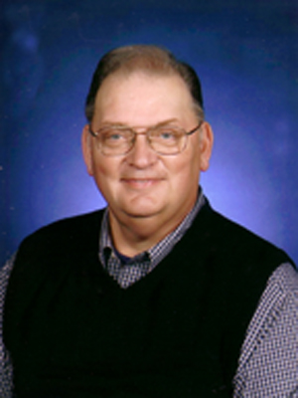
Sam Crain, President
North Carolina Federation of Chapters

Sam was born on June 25, 1942 in Memphis, TN. He graduated from Whitehaven High School and Memphis State University. Both of his daughters – Karen and Jennifer – received their undergraduate degrees from Memphis State University. Sam’s wife, Kitty, graduated from the University of Tennessee in Knoxville, which makes for some great dynamics when watching sports on TV. Sam did not leave Memphis until 1996 when he and Kitty moved to Jackson, TN. In May, 2001 they moved to Maggie Valley, NC, where they live in a 150 year old log cabin in the mountains.

In November, 1963, Sam joined the Air Force Reserve and started a 38 year career in the military. He transferred to the Tennessee Air National Guard two years later after the Reserve unit closed. In 1969, Sam was offered a full time position as a Civil Service employee. In 1999, he retired from the unit with 30 years of Federal Civil Service. Sam spent the first 19 years as an enlisted person going from Airman Basic to Master Sergeant. After graduating from Memphis State University with a BBA in Accounting and Financial Management, he received a direct commission as a Captain and 19 years later retired as Lt Col. His civil service and military careers went from fueling airplanes to serving as the Comptroller/and Financial Manager for the 164th Airlift Wing in Memphis, TN.

After retirement, Sam joined NARFE as a Life Member and has served as Vice President, President, and Service Officer and as Sunshine Chairman with Chapter 1420, Smoky Mountain Chapter in Waynesville, NC.

Eight years ago, Sam was elected Federation Treasurer and has now served for the last two years as your Federation President. Sam has enjoyed traveling throughout North Carolina, spending time with other NARFE members to raise awareness of Federal Employees and Retiree’s earned benefits. Thank you for that opportunity!

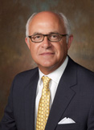
David W. Combs
Mayor, Rocky Mount, NC

- Elected to Rocky Mount City Council in 2003

- Elected Mayor of the City Of Rocky Mount in 2007 and currently serving as the Mayor, the Vice-Chairman of the Carolinas’ Gateway Partnership Economic Development Corporation and the Chairman of the Rocky Mount Business Development Authority

- Serve on the Board and the Executive Committee of the North Carolina Metropolitan Mayors Coalition as their Treasurer

- Served as a member of the Board of Directors for the North Carolina League of Municipalities

- Married to Catherine Combs and have two daughters Mollie and Maggie, a son Blake and two grandsons Landis and Cooper.

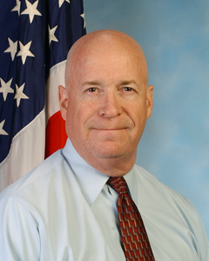
William "Bill" Shackelford

FEDERAL SERVICE
During my nearly 35 years of service with the FBI, I served in various training, analytical and management positions, including review and distribution of records relative to the assassination of President John F. Kennedy, training in the archival preservation of historical records and the management of litigations filed under the Freedom of Information and Privacy Acts. I retired in January, 2006.

NARFE EXPERIENCE

- CHAPTER
- Member of Fairfax Chapter 737 since 2005.
- Served the Chapter in many positions including:
- President
- Vice President
- Newsletter Editor
- Service Officer
- FEDERATION
- Served the Federation in many positions including:
- President
- 1st Vice President
- 2nd Vice President
- NATIONAL
- 2012 National Convention - Chair of Timekeeper Committee
- March 2013-Appointed Chair of National Bylaws Committee
- August 2013-Appointed Co-Chair of "Future of NARFE" Committee
Jessica Klement
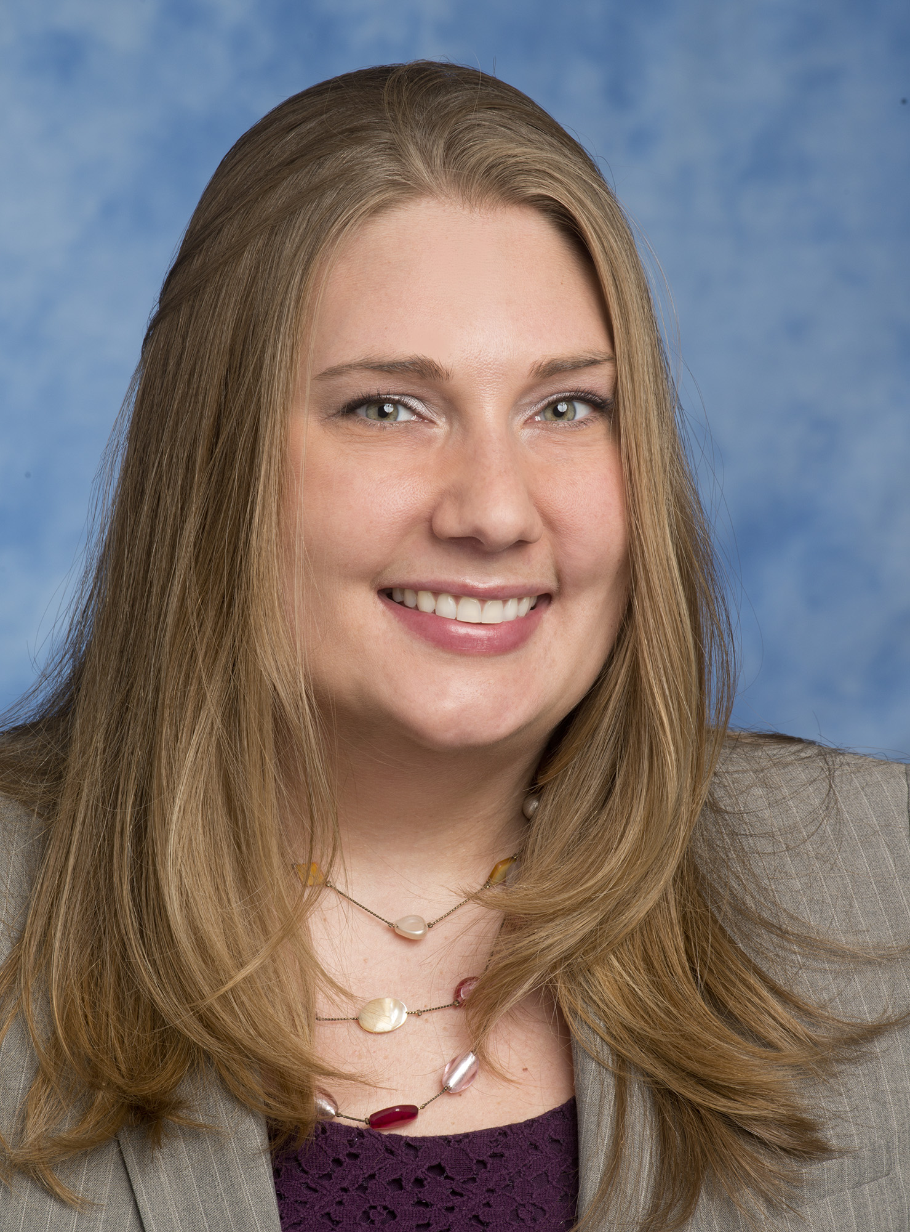
NARFE Legislative Director
Jessica Klement joined the National Active and Retired Federal Employees Association (NARFE) Legislative Department in April 2012, serving as its Communications and Legislative Representative. She was promoted to the position of Legislative Director in December 2012.

Klement began her fore into the Washington political landscape as an intern for Congressman Tom Petri (R-Wis.) in 2001. Petri is a senior member of the House Transportation and Infrastructure Committee, Chairman of the Aviation Subcommittee, and also a member of the Education and the Workforce Committee. Upon graduating college in 2002, she was hired as a full time Caseworker in the Congressman’s office to handle immigration, Social Security, and related Executive Branch matters for constituents of Wisconsin’s Sixth District. Klement then earned the opportunity to dive into the legislative process and policy analysis as a Legislative Correspondent drafting responses to constituents’ legislative inquiries. Eventually, she served as Mr. Petri’s Legislative Assistant handling issues relating to the House Judiciary Committee.

Prior to making her way to NARFE, Klement most recently served as the Government and Public Affairs Director at the Federal Managers Association for five years, and was with the Association for nearly seven years. In this role, she served as FMA’s primary lobbyist on Capitol Hill, coordinated the activities of FMA’s political action committee, handled FMA’s media relations, and provided policy analysis on a range of issues. She worked closely with Members of Congress and their staff in drafting legislation pertaining to federal employee and retiree benefits, as well as prepared congressional testimony for FMA leaders for presentation before the House and Senate. In particular, Klement worked directly with congressional staff to craft and ultimately pass legislation crediting FERS employees for unused sick leave at the time of retirement.

Klement hails from Waukesha, Wisconsin, and graduated from Marquette University in 2002 with a Bachelor of Arts degree in Political Science and a Bachelor of Science degree in Finance.

William F. Martin
Region X Vice President

Bill joined NARFE in 1992 upon retiring from the US Postal Service with 30 years’ service. He has held various NARFE positions including chapter membership chair, chapter president, and Virginia Federation President.

Elected at the 2010 national convention he now serves as Region X Vice President. Bill is involved in his community as Louisa County Planning Commissioner and is treasurer of two local non-profit organizations.

Bill has five children, seven grandchildren and five great grandchildren.

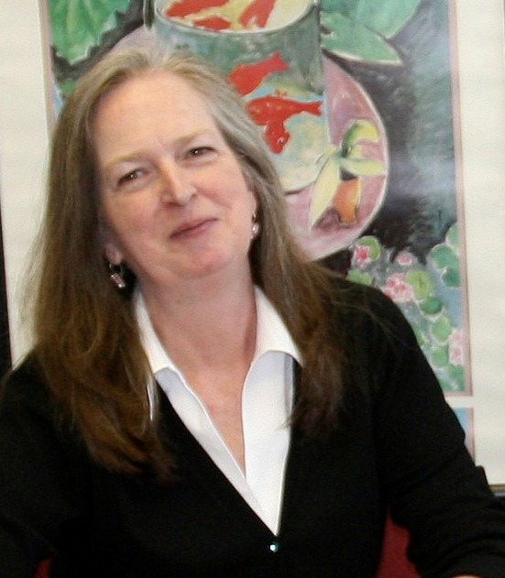
Bridget Boel
NARFE Membership Director

Bridget Boel is the NARFE Director of Membership. Bridget, who joined the NARFE staff in March of 2012, oversees Recruitment & Retention, Advertising, Member Records, and Federation & Chapter Services.

Bridget has extensive marketing experience in both corporate and association environments. She began her career managing renewals with Ziff-Davis magazines. She went on to hold numerous marketing positions with Time Life, Inc., to direct the publishing and marketing departments for the National Head Start Association, and to develop research and strategic plans as a marketing consultant.

THE LYLE V. STORCH AWARD
Lyle V. Storch, who lived in Durham, NC, was an ardent member of the National Active and Retired Federal Employees Association (NARFE) and worked tirelessly at all levels of government: city, county and state, for those issues he felt strongly about.

Yet, only a few knew of his efforts outside of his family, friends, and associates. He worked effectively both behind the scene and on the stage. The few examples noted below outline how he made a difference in his community, area, state, and other organizations he served along with NARFE.

The City of Durham was fortunate to have him as a citizen, as well as serving its citizens. He was a member of the Council for Senior Citizens, taught defensive driving for AARP, and worked to establish the Center for Seniors in Durham. He served on many boards and committees in and around the Research Triangle Area and North Carolina, including the Triangle J. Council of Governments’ Aging Advisory Committee and the state Attorney General’s Senior Fraud Task Force.

As a young man, he served his nation through military service, first serving in the Army during the Berlin Air Lift and then transferring to the Air Force. His military experience led to a civilian career with the Federal Aviation Administration.

His passion for fairness and openness in government put him at the center of the Bailey Settlement action. He worked tirelessly lobbying the state legislature and generating grassroots support for tax equality. Eventually, the court directed settlement returned illegally collected state income taxes on the annuities of many retired federal employees in North Carolina.

His service to NARFE included serving as Durham’s Chapter President, NC Federation of Chapters Executive Vice President and President.

More than anything else, Lyle Storch’s consistent work on behalf of state, local, and organizational issues and concerns confirmed his commitment and also reinforced his “can do and will do” attitude that is so necessary to getting things accomplished.

While no formal criteria exists for selecting a candidate from the nominees for this award, the nomination form uses the example set by Lyle V. Storch as a guide in the selection process. “Service to NARFE and the member’s local community will be considered in the selection process.”

LYLE V. STORCH AWARD RECIPIENTS
2002 William Cannon Cape Fear Chapter 0276
2003 Kenneth Strawberry Wilmington Chapter 0337
2004 Clarence Burrell Smoky Mountain Chapter 1420
2004 Charlie Pratt Raleigh Chapter 0192
2005 Julian Oliver Henderson Chapter 2289
2006 Milton H. Quinn Marjorie Christie Chapter 1999
- Brevard

2007 Inez R. Angus Smoky Mountain Chapter 1420
2008 Barbara Holden Rocky Mount Chapter 0781
2009 Thomas N. Hobgood Raleigh Chapter 0192
2010 Paul H. Carew Pearl S. Wright Chapter 2108

2011 Robert F. Bartlett Coastal Chapter 1312

2012 Paul E. Sams Sandhills Chapter 1895

2013 Carolyn C. London Durham Chapter 0566

The Charles R. Patton “Good Egg” Award

The purpose of this award is to recognize NARFE members who have made significant and sustaining contributions to the federation, chapters, and its members. Recognition will be in the form of a “Good Egg Plaque” presented at the annual federation convention. The award is given to the nominee who is judged by committee to have made the most outstanding contributions in support of NARFE’s goals and objectives.

Criteria for selection will be based on achievements and contributions that go beyond general expectations and reflect quality, excellence, and innovation and make significant contributions to some aspect of NARFE’s mission. Criteria for Judging:

- The impact and significance of the contribution to NARFE whether at the chapter, area, or federation level;
- The planning and/or strategy efforts involved in the project (s) or program(s);
- Description of the execution or delivery of the program or project and the extent of the involvement of others;
- Description of the publicity or public relations generated by the program or project;
- Positive recognition and/or expressed appreciation of the program or project by others.

CHARLES R. PATTON AWARD RECIPIENTS

Charles Alexander Rose S. Olynick
Bill R. Austin Lee R. Paramore
Shirley Bales Elsie M. Parker
Alex Bourdas Charles R. Patton
Edmund Bromley Jerry Pifer
Lillian Creger Edward R. Piper
Charles H. Dickens Milton Quinn
Walter Fuller George W. Sabo
Catheryn Garrison Mary Simpson
Avery Ghent Delores Smith
Fain Hambright Milton Smith
Henry Harbuck Milton Stone
George R. Hatcher Lyle V. Storch
Alvea Hearren Robert C. Thatcher
Thomas N. Hobgood Helen C. Wallace
Barbara Holden Louise Warren
Elaine Hughes Betty J. Whitten
Joseph Kelly Pearl Wright
Melvin H. Kolbe Marian E. Zang
Charles L. Lehning
Percy Lehning Honorary:
Roy Lovvorn Mr. & Mrs. James B. Mong
Aileen E. McGraw

PAST PRESIDENTS OF THE
NORTH CAROLINA
FEDERATION OF CHAPTERS

YEAR(s) PRESIDENT
May 1965 - May 1967 J. C. Gay
May 1967 - May 1968 Boyce Moore
May 1968 - May 1970 J. Eddie Robbins
May 1970 - May 1972 C. F. Parrish
May 1972 - May 1975 T. J. Cheek
May 1975 - May 1976 W.M. Whittington
May 1976 - May 1977 Albert Wagner
May 1977 - May 1979 Charles R. McCarthy
May 1979 - May 1980 O. J. Huffman
May 1980 - May 1983 Charles Lehning
May 1983 - May 1984 Aaron Berryhill
May 1984 - May 1986 Charles Alexander
May 1986 - May 1988 Elsie Parker
May 1988 - May 1990 Alex Bourdas
May 1990 - May 1992 Milt Quinn*
May 1992 - May 1994 Ed Bromley
May 1994 - May 1995 Elsie Parker
May 1995 - May 1997 Fain Hambright
May 1997 - May 1999 Lyle V. Storch
May 1999 - May 2001 Bill R. Austin*
May 2001 - May 2003 Lillian Creger*
May 2003 - May 2005 Sarah Gonzales*
May 2005 - May 2007 Thomas N. Hobgood*
May 2007 - May 2008 Paul H. Carew*
May 2008 - May 2010 Elaine Hughes*
May 2010 - May 2012 Paul E. Sams

* Living Past-Presidents

2014 NC FEDERATION CONVENTION
PLANNING COMMITTEE

Sam Crain President

Ron Buffaloe Executive Vice President

Carolyn C. London Secretary

Gracie W. Couch Treasurer

Robert Allen 2014 Host Committee Chair
and Host Area Vice President

Charles Pratt Technical Advisor/Webmaster

Doris Maxwell Public Relations Officer

Sue Hawkins 2015 Host Committee Chair

Steve Kesselman 2015 Host Area II Vice President

Area IV Steering Committee Members
Charles Pratt Goody Bag Chair
Ruth Ann Kleinfelt Member
Sandra Tucker Member
Bryant Tucker Member

And many others across Area IV and the state whose guidance
and assistance helped make this convention possible

2014 NC FEDERATION COMMITTEE MEMBERS

Audit
Chair: EVELYN A. ELLIS – Area IV
Advisor: TOM JENNINGS
Area I: SANDRA RUMSEY
Area II: JOYCE JAEGER
Area III: JOHN KOIVISTO
Area IV: EVELYN A. ELLIS
Area V: EDWIN S. DEAVER
Area VI: KEVEN S. TRUNDY

Budget
Chair: MERRILL JACKSON-Area IV
Advisor: SUE WYATT
Area I: DAVID WRIGHT
Area II: VINCENT COMPARATO
Area III: DAVID SPANGLER
Area IV: MERRILL D. JACKSON
Area V: GLENN MARSHALL
Area VI: RUTH KYLE

Courtesy
Chair: SHARRILL JENNINGS– Area V
Advisor: JOANN TADLOCK
Area I: MARY J. WRIGHT
Area II: MARY NAPIER
Area III: DAWN ALLRED
Area IV: RICHARD PULSIFER
Area V: FRANCES DENNINGER
Area VI: SANDY TRUNDY

Ballot and Teller
Chair: HARRIETT BARTLETT – Area V
Advisor: LINDA PRATT
Area I: CLARENCE BURRELL
Area II: WILLIAM MANNING
Area III: SUSAN KOIVISTO
Area IV: BILL LAMM
Area V: HARRIET BARTLETT
Area VI: JAMES SEARS

Bylaws
Chair: BILL R. AUSTIN – Area II
Advisor: FREIDA TERRELL
Area I: GWILLI GERICHEK
Area II: BILL R. AUSTIN
Area III: HERBERT J. LIEBERMAN
Area IV: SANDRA L. TUCKER
Area V: SARAH E. GONZALES
Area VI: JAMES H. KIMBLE

Credentials
Chair: TOM ROGERS – Area VI
Advisor: CHARLES D. PRATT
Area I: RICHARD KENT
Area II: VIVIAN VAIR
Area III: COY RAHMAN
Area IV: TIM STONE
Area V: SYLVIA AUTEN
Area VI: TOM ROGERS

Legislative
Chair JOHN ALLIS – Area IV
Advisor: DAVE MOULTON
Area I: TED L. MATHIS
Area II: WALTER F. GRIMES
Area III: SUE SLOOP
Area IV: JOHN ALLIS
Area V: JAMES R. AUTEN
Area VI: FRANK BURK

Resolutions
Chair: BETTY WHITTEN-Area III
Advisor: ROGER QUINCOSES
Area I: RAYMOND CARTER
Area II: ANNIE BOONE-CARROLL
Area III: BETTY WHITTEN
Area IV: JAMES R. DOWNEY
Area V: JULIA WHEELER
Area VI: WARREN SAFFELL

Sergeant-at-Arms
Chair: NATE JOHNSON - Area IV
Advisor: THERON RUMSEY
Area I: THERON RUMSEY
Area II: BOB HOLZMANN
Area III: BENNIE SAUNDERS
Area IV: HENRY BRATTLIE
Area V: WALTER DENNINGER
Area VI: JOHN THOMPSON

Nominating
Chair: SUE HAWKINS- Area II
Advisor: PAUL E. SAMS
Area I: INEZ R. ANGUS
Area II: PATSY BOYLES
Area III: JERRY PIFER
Area IV: FREDERICK A. HAWKINS
Area V: AUSTIN L. WASLEY
Area VI: PHILIP W. TREADWAY

Rules
Chair: WALTER R. MACK – Area IV
Advisor: THOMAS N. HOBGOOD
Area I: JAMES E. FOX
Area II SONIA RICHARDS
Area III: JAMES L. WHITTEN, SR.
Area IV: WALTER R. MACK
Area V: ROBERT BARTLETT
Area VI: NANCY BATCHELOR

Our Appreciation and Thanks To:

- The Planning Committee for their time, energy and attention to detail in organizing this convention in the beautiful Rocky Mount area; for designing a convention to provide information as well as enjoyment; and in diligently seeking speakers of interest relevant to our attendees;

- The Gateway Centre Hotel Complex, and David Joyner, Marketing Director, for their cooperation, support and concern in ensuring excellent facilities and service;

- Blue Cross Blue Shield for helping host our reception, providing door prizes and their continued support;

- The many advertisers and to our chapters for their continued outstanding support;

- The exhibitors for providing information and prizes for our convention participants;

- Our many members, spouses, guests and friends of the North Carolina Federation for their time and support by attending this convention;

- The local officials and community leaders of the Rocky Mount area for their warm welcome and assistance with our opening ceremonies;

- The Northern Nash High School Junior ROTC for posting the colors and the Tar River Swing Band for providing musical entertainment; and

- The many speakers, for sharing their time and expertise with us during this convention.

Welcome
To The
58th Annual
North Carolina Federation Of Chapters
Convention

“Respecting The Past –

Creating The Future”

RECRUIT - - RETAIN - - DEVELOP
"The Future Is Now - -
Let's Move NARFE Forward"

William “Bill” Shackelford

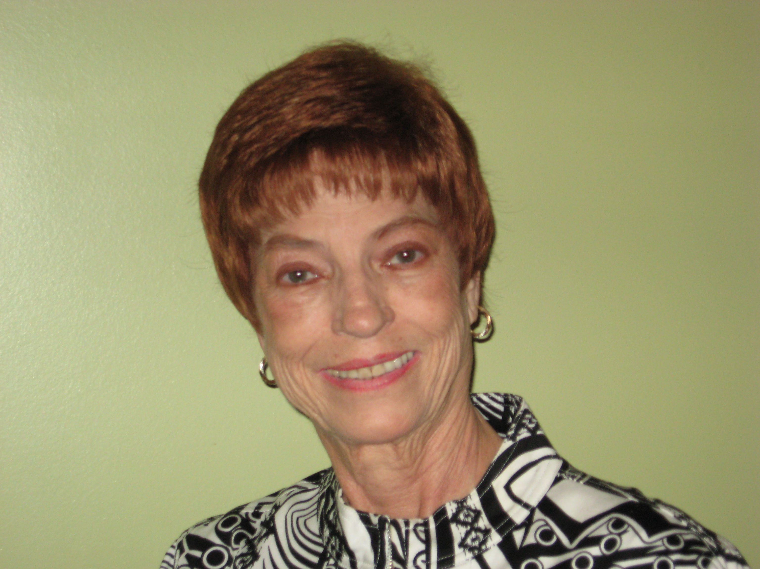
Mary Pierson
Candidate for Region II Vice President

My federal career started in 1961 at Keesler AFB and then in 1974 transferred to the U.S. Naval Oceanographic Office, Stennis Space Center, MS.

Throughout my 36-year career as a federal employee, I wore many hats, from Personnel Specialist and Contracting Officer and Ammunitions Officer. As a Command Inspector, I traveled to every continent except Australia to inspect the twelve Naval Oceanographic Ships. I retired after 36 years of service to our country in December 1997.

I attended college at the University of Southern Mississippi and Mississippi State University and have earned 32 Certificates of completion from the Air Force and the Navy on courses I completed that enhanced my position with DoD.

My career with NARFE started in 1998, serving my Chapter as President. Attending the 1999 Mississippi Federation Convention, I was appointed as the Federation Membership Chairman. In 2003, I was elected as 2nd Vice President of the Mississippi Federation, and in 2004 I was elected as the Federation President. As Federation President I had the pleasure of establishing the first NARFE all active federal employee chapter at Stennis Space Center. During this same time, I served NARFE National as the Region III Pre-Retirement Seminar Coordinator and assisted Director Ken Glass. When Ken retired I was asked to accept the office of Director of Pre-Retirement Seminars.

I have attended all NARFE Conventions, both National and Federations since 2000 to increase my overall knowledge of NARFE.

My in-depth knowledge and understanding of NARFE’s goals and operation, my formal education along with my federal employee experiences qualifies me as a candidate for the office of NARFE Region II Vice President.

I am committed to Expanding our membership in NARFE

I will work to Develop better communications with our elected officials, National and State Congressman and Senators.

I will interact with you on your ideas to improve NARFE overall.

I will work with you to grow the membership in Region II.
I will be available to you at all times via cell phone and computer.

I grew up in San Francisco, CA, graduated from Galileo High School. I met my husband Donald and moved to Gulfport, Ms. We have one daughter, two sons and four adult grandchildren.

Make Plans Now to Attend the 59th
North Carolina Federation of Chapters
Annual Convention

May 5-7, 2015

Area II looks forward to hosting you in the
Crowne Plaza Hotel
1385 Lenoir Rhyne Blvd. SE
Hickory, NC

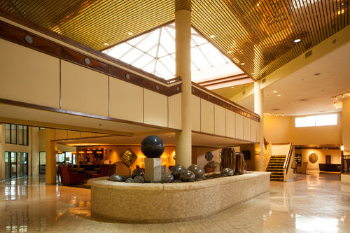

Sue Hawkins, Host Committee Chair
Steve Kesselman, Host Area Vice President

Area II Chapters

Albemarle Charlotte Hickory
Lincoln County Piedmont-Gastonia
Salisbury Stanly County

NOTES

______________________________________________________________________________________________________________________________________________________________________________________________________________________________________________________________________________________________________________________________________________________________________________________________________________________________________________________________________________________________________________________________________________________________________________________________________________________________________________________________________________________________________________________________________________________________________________________________________________________________________________________________________________________________________________________________________________________________________________________________________________________________________________________________________________________________________________________________________________________________________________________________________________________________________________________________________________________________________________________________________________________________________________________________________

NARFE
North Carolina Federation of Chapters

0105 CHARLOTTE II 1312 COASTAL V
0156 CHARLES R. PATTON I 1420 SMOKY MOUNTAIN I
0192 RALEIGH IV 1530 PITT COUNTY VI
0211 GREENSBORO III 1611 SURRY-YADKIN III
0214 HENDERSONVILLE I 1791 PIEDMONT-GASTONIA II
0276 CAPE FEAR V 1830 WAYNE COUNTY IV
0337 WILMINGTON V 1894 BRUNSWICK COUNTY V
0454 WINSTON-SALEM III 1895 SANDHILLS V
0566 DURHAM IV 1904 LUMBER RIVER V
0667 MARION I 1983 LINCOLN COUNTY II
0668 HIGH POINT III 1999 MARJORIE CHRISTIE I
0692 HICKORY II 2046 SAMPSON-DUPLIN V
0696 BURKE COUNTY I 2107 JOHNSTON COUNTY IV
0720 SALISBURY II 2108 PEARL S. WRIGHT IV
0781 ROCKY MOUNT IV 2206 FIRST FLIGHT VI 0800 ASHE-ALLEGHANY III 2209 CAROLINA MOUNTAIN I
0804 WASHINGTON VI 2211 HAVELOCK-CHERRY PT. VI
0808 NEW BERN VI 2266 INTRACOASTAL V
0826 SANFORD V 2289 HENDERSON IV
0979 WILKES III 2295 PERSON-CASWELL IV
1005 ALBEMARLE VI 2297 ROANOKE VALLEY IV
1161 ROCKINGHAM COUNTY III 2316 STANLY COUNTY II

The Mission of
the National Active and Retired
Federal Employees Association IS:

- To support legislation beneficial to current and potential federal annuitants and to oppose legislation contrary to their interests

- To promote the general welfare of current and potential federal annuitants by advising them with respect to their rights under retirement laws and regulations

- To cooperate with other organizations and associations in furtherance of these general objectives

We hope you enjoyed the 58th annual convention -
Thank you for your support.

Special acknowledgement

Whistle Stop Press
175 Davis Road
Southern Pines, NC 28387
(910) 692-8366
www.gowhistlestop.com

